The Butterfly Effect of Biotech: How Innovation that is Centered Around Improving and Saving Life Maximization Faces a Multifaceted Paradox and Macro Scarcity due to Inefficient Markets

Nicholas Jones

EC 480: Research Seminar in Economics and Finance

05/09/2025


John Cabot University

Bachelor of Arts Economics and Finance

Table of Contents
Dedication……………………………………………………………………………3
Acknowledgements………………………………………………………………..4
Abstract……………………………………………………………………………….5
Introduction and Motivation…………………………………………………….9
Research Question and Hypothesis………………………………………..28
Literature Review…………………………………………………………………32
Methodology and Data Sources………………………………………………35
Regression Analysis……………………………………………………………42
Extended Regression Analysis: Key Insights, Butterfly Effect of Innovation, and Conclusion…………………………………………………..56
Limitations………………………………………………………………………… 60
Appendix…………………………………………………………………………….61
Bibliography…………………………………………………………………………65
Dedication
N/A

Acknowledgements
N/A

Abstract
Time is the most essential aspect of humanity. All our wants and worries are luxuries through the lens of time. It is said that time is a resource that we cannot buy, yet I would argue this assumption (from a relative standpoint of course.) I believe that innovation in the healthcare sector can be directly attributable to the act of buying time, as this is an innovative endeavor that can greatly prolong or enhance one’s life. This paper argues that the U.S. biotech sector, a critical engine of life-saving advancement, is held hostage by cyclical financial pressures rooted in monetary short-termism and cyclical emotionalism thereof. So why does our current economic system not account for humanity’s most essential and finite resource?
This paper explores how macroeconomic conditions, from interest rates to inflation and capital market dynamics, contribute largely to the rate at which biotech innovation is actualized. Revolving around the United States market (for the sake of this paper), I will analyze how sector-specific financial pressures, investor sentiment, and the broader economic climate interact to either create an environment in which innovation is coveted, overlooked, and or (in the worst instances) paradoxically and negatively affected (in a compounding manor), for while these companies’ equity and asset valuations are dependent on cash flows and the potential thereof, their cash flows are dependent on the equity valuation and financing that they receive for the clinical phase assets that are perceived to be the potential cash flows. This is done by examining the risks and scale of investments that follow during macroeconomic volatility and directly trickle down to innovation in biotech by setting the landscape in which micro-small cap companies have to navigate (rising costs along with inflation and harder financing conditions to counteract this inflation and the equity sentiment that follows) and how the asset analysis thereof, largely requiring niche analysis to be successful and reputable that is not commonly found in the market, creates the investor value of the company, and assets thereof, that will create the perceived value that the company will then navigate its clinical assets with (making financing or other means of raising money for these clinical trials either more or less viable based on the company’s equity valuation.)
All in all meaning, the sector is sucked of its innovation by times of unaccommodating governmental policy and lack of knowledge from the general investor in the analysis of clinical phase assets. Simply put, macroeconomic pressures not only shape the financial viability of innovation capacity of micro and small-cap biotech firms but also are a deterministic metric in large scale prediction of performance and the innovation that follows. Thus, the innovation in the sector is not solely based on intellectual or technological capabilities, but the current macroeconomic climate that the federal government is supposed to be protector of. So why is viability of investment (or even overall investment as a marker for viability) in biotech not a consideration for economic policy that lays the groundwork for innovation through lifesaving and quality of life maximization?
As previously stated, these companies and timelines face a paradoxical endeavor based upon potential cash flows and the viability of actualization (independent of the capability of the asset itself at times or in the effect of totality) as it pertains to the accumulation of concentrated investments and equity valuations that are essential for the cash runway that the company will experience. The cash runway is necessary for the viability of innovation, as it is the capital used for the clinical phases of the clinical phase assets (markers of innovation-as they are the advancements in the sector) that will be the potential cash flows that the companies are valued based on. Meaning that the necessity for institutional concentration of investment (which is a common practice of Venture Capital (VC), private equity (PE), and banks alike), and expertise in asset analysis is in large creating a knowledge gap for most investors in biotech making the need for financial intermediation a prevalent endeavor. Furthermore, why is there not a financial derivative in which not only concentrated investment becomes more viable through the ability to easily hedge one’s concentrated investment and profit off of the skew of successful investments and cash flows compared to unsuccessful investments (and the percentage of gains to losses that are experienced thereof over the long term), but also investment in general is also more easily accessible and the loans from potential equity that is not public is easily investible not only helping the company(s) evaluations directly, due to the cash runway that this will provide, but allowing these companies to IPO at optimal times instead of times of desperation-leading to undervaluation’s that, as stated above, will have a compounding and paradoxically inverse effect on their evaluations moving forward.
Paradoxical effects compounding inverse to the alleviation of pressure that these companies would face, or lack thereof, if the proposed vehicles and accommodations were set in place above. As, since these companies (micro-small cap biotech) are dependent on financing and equity valuation and investment to have a sustainable cash flow, yet NPV is derived from cash flows (or the prediction thereof) you can begin to see how this paradox creates an exaggerated butterfly effect in which the macroeconomic landscape can trickle all the way down and effect the innovation in the Biotech sector by either creating a euphoric (optimistic) investment outlook or fearful (pessimistic) outlook based on the macroeconomic condition of the time and not the actual innovation, actualization percentage, and lucrative actualization thereof of the assets and their viability to establish revenues and cash flows in their respective indications.

Introduction and Motivation
If I offered, you a billion dollars with the caveat that you would not wake up tomorrow. Would you accept this offer (assuming that a billion dollars is a substantial increase in net worth of course)? This is a thought experiment that leaves us with the universal truth that the essential aspect of life is time, and the essential aspect of time is health. Yet, our economic systems are not revolvant around the perseverance and cultivation of the most valuable resource known to man. Nowhere is this example more exacerbated than in the biotechnology sector where the stakes are not incremental conveniences that can optimize or enhance our realities but are the gatekeepers responsible for the preservation of our very reality and the line between life and death. This paper hypothesizes the argument that macroeconomic cycles and investor sentiment, rather than scientific and technological capability, are the primary determinants of the rate at which biotech innovations reach patients-and when.
While beauty in the biotech sector (mainly in the United States as this will be the central market for the argument of this paper) for the niche domain knowledge-investor or speculator alike can often be outlined by the Sector’s independence or alpha from general macro market movements and thus individual company alpha not common in other sectors (often under the motivation of binary outcome analysis of clinical trials.) Yet, the overall macro climate is in many scenarios indicative of the dependence of asset evaluation and thus revenue streams/ cash flows projected and current that is often seen in this sector-independent of the market in many instances. Meaning that there is alpha to be found in these evaluations on a micro level for the niche knowledge investor, yet for the sake of overall innovation in the sector one would find a large impact due to the macro environment found in the market and the butterfly effect thereof. In this paper, I will be exploring the impact of the macro climate in the biotech sector either from a butterfly effect point of view and or direct impacts from over/under-evaluations and the underlying market conditions that cause these over/under-evaluations and what they entail for company, and therefore, sector performance and how this performance impacts sector innovation based on perception and direct evaluations.
Furthermore, the macroeconomic conditions of any environment will impact the innovation in that sector whether this impact is a butterfly effect, or a direct effect similar to the wealth effect, in which the macroeconomic climate can make some economic/financial decisions more or less viable dependent upon the borrowing rate to rate of inflation of today, as well as the staggering rate effects of the ratio of these metrics in the past, while also taking into account the opportunity of investment into other equities, and at times other securities that can be seen as comparatively safer during times of higher interest rates, and expectation thereof i.e. treasury bonds/rates (even inflation expectations through treasury inflation protected securities (TIPS) and breakeven inflation rate (BEIR) which are key indicators in the projection of inflation and thus potential interest rates used to counteract.) In addition, it is important to understand that in the same way that some macroeconomic climates are more viable for innovation or startups in any sector the same goes for biotech micro-cap (a publicly traded company within the market cap of sub 50 million ((generally speaking) which makes up roughly 75-80% of companies in the sector) and small market (a publicly traded company within the market cap of 50 million to 500 million market cap (which makes up roughly 15-20% of companies in the sector) in which company growth is easier during times of economic growth, or when the interest rates are relatively lower and inflation is relatively higher while the U.S. dollar is relatively weakening (although this paper may be transmittable to other market outlooks/outcomes I will centrally be focusing my idea around the Biotech sector in the U.S. as well as macroeconomic conditions that mainly pertain to the U.S. as mentioned above.)
I believe that it is essential that I share the basics of asset evaluation in the sector first and provide some intuition into the levers thereof. As stated above, this is a highly unique sector that experiences high binary volatility of asset valuation and market movement for publicly traded assets, yet private fluctuations in value are also experienced through clinical binary outcomes that are not common in other sectors. A company achieving success in any given clinical phase can further enhance its clinical asset evaluation, and thus its overall value making the viability of success easier through means of future funding towards its cash runway (cash runway meaning the cash the asset has on hand to use to accommodate the costs of its clinical pipeline.) Why is this? As I have somewhat touched on in the abstract, these micro-small cap biotech companies are valued based on the potential cash flows of their pipeline and often do not have a drug on the market yet. What does this mean?
In biotechnology, asset analysis is fundamentally different from traditional sector analysis. The company value is tied to its assets in the pipeline that are dependent on potential cash flows when they are still in the clinical trialing phase (before they are approved.) These cash flows are dependent on a multitude of criteria that create the present value of the asset today. If you think of a traditional discounted cash flow model (DCF), the two most important factors of the model to quantify the present value of the company’s future cash flow today are the growth rate and the discount rate. Yet, for biotechnology micro-small cap stocks do not always have cash flows that are already established so it takes niche domain knowledge to be able to project the value of any given asset in the company’s pipeline and thus the company’s future value projected and the NPV thereof (while also taking into account the probabilities of clinical success of said asset.)
This cash flow is dependent on many factors that can make the NPV highly variable between any given investor: Meaning that depending on the total addressable market (TAM) of the given mechanism of action’s (MOA) indication (what the drug targets as its therapeutic activation or target i.e. obesity would be an example of an indication.) Which has its own individual patient population that can be labeled under the potential patient population of the indication depending on their current health status or even the individual patient variability thereof. Which also has a growth rate that can be attached to it, which should also be considered when projecting the future potential cash flow of a given assets value today as the current market TAM is unlikely to be the TAM when the given asset will reach the market. For longer term asset evaluation, it is also viable to perceive certain patterns in habits of populations that lend themselves towards becoming more susceptible to being a part of the addressable market and thus cultural and societal habituality is of key importance in some instances as society may be leaving their bodies susceptible to becoming a part of the given indications therapeutic target (i.e. for the obesity indication I would point to the western diet being scientifically attributable towards obesity as well as the habits of western societies and societies alike.)
Next is the market share projected, which is based on several factors that vary from supply constraint, other assets in the indication, and variability in the indication or the viability/ low costs of the given asset under evaluation’s ability to produce the drug. Furthermore, any given MOA may have manufacturing or cost complications that cap the market share that the drug would even be able to address even if it was the best drug in the market at the time of approval. Often the most important factor is competition as it pertains to efficacy, safety, costs, convenience of the routes of administration (staying in obesity indication as our example you have intravenous, subcutaneous, or oral administration- oral obviously being preferred by the patient population), and chemical viability of production, that the company has as it pertains to manufacturing or other possible connections that may make any given asset more viable to capture a larger percentage of the TAM, or as many would say market share. And, it is not enough to know how the asset compares to the current indication’s drugs that are on the market today, you also need to look at the timelines of the clinical assets in the indication and see how the asset under question compares to the drugs that will be on the market or finish clinical trials at relatively the same time, 1 year after, 2 years after, 3 years, and to infinite, as it pertains to the indication you have a vested interest in through the asset under question (of course assuming that the asset under question has passed the other criteria that I will continue to lay out.) This will be essential in gaining an idea as to what market share this asset will realistically hold.
The next step in your analysis is a given drug’s clinical efficacy. The later and more extensive the clinical trial the more important and more weight this variable will hold into being able to compare statistics/efficacy with the given asset to the assets that are also in clinical trials and the assets that are already on the market that would be its direct competition for market share, as I touched on above. This is a highly important variable yet is often projectable if you have a grasp over possible skewing in the data as it pertains to patient population ((and how a certain patient population’s baseline characteristics may skew the data results due to the vitals that they have before the clinical trial phase that the data comes from (their previous health leaving them more or less susceptible to the MOA and endpoints observed during the trial)) and placebo adjustments that I will leave to interpretation for the sake of this paper. The length of the trial- phase 1 being the shortest (roughly a couple of weeks generally), phase 2 being a little more extensive (months generally), and phase 3 being the most extensive (usually multiple months to years of clinical results.) Obviously the shorter the clinical trial the less reliable the data is (also taking into account potential plateauing in the MOA’s as it pertains to any given efficacy results, but it’s not that simple, as each clinical phase has its own purpose and depending on the unknown of the drug that the company has produced the primary endpoint (the main measurement of efficacy that the FDA has agreed is a good indicator of drug activation and efficacy for any given clinical trial) and secondary endpoints (either supplementary or can be seen as a potential substitute to the primary endpoint in future clinical trials if the drug does not show efficacy in the primary endpoint-great enough to suffice the criteria laid out before the clinical trial- and thus another clinical trial may be deemed required by the FDA to move on to the next phase of clinical trials) may be subject to change or different to the endpoints commonly used in the indication (slightly or drastically.) Leaving the analyst to be forced to compare two different athletes that may have two different sets of rules, with different equipment, different coaches, and one of the athletes may be using performance enhancements depending on the origin of the clinical trial (looking at you Australia and China-it’s a long paper I need to have a little fun.) Which leaves me to a brief point that I would like to touch on as it pertains to efficacy and overall clinical trial results-in that the origin may leave the asset susceptible to scrutiny as it pertains to accuracy in the results that are conveyed in the clinical trial for investors, yet this is a market nuance ever changing and somewhat opinionated, as it pertains to how drastic, thus I will leave this up to individual interpretation.
The asset’s safety profile which is essential to even be considered viable as a competitive asset in the given indication (and to pass preclinical phases or any phase thereafter-in which phase 1 and 2 are centrally observing the safety profile over efficacy) for obvious reasoning in that the asset needs to be safe before the efficacy is even a factor ((meaning safety and efficacy could be interchangeable in the order that you analyze, or importance in the analysis as it pertains to asymmetry thereof, compared to market analysis, of the clinical asset-depends on nuances in the individual asset or the indication. For example, I would point to CB1 obesity drugs- in which clinical safety is of upmost importance and efficacy is at large an afterthought due to the historic prevalence of the MOA but reasoning for prevalence changes with different analysis. When it comes to the modification of biology or enhancement it can be somewhat uncharted especially as it pertains to new MOA’s and the treating of indications that do not currently have a proven MOA or have a treatment that is relatively efficacious. Moving on, there is somewhat a balancing act depending on severity of the safety profile and the drug’s competitiveness of its efficacy profile as it pertains to market competition with other assets for market share of the indication for investors to gain a central grasp of the competitive landscape of that asset and how the asset in question may compete for market share. Many of the same factors and intricacies go into projecting the safety profile of the given asset, yet keeping an eye for serious adverse events (events that surpass more welcomed AE’s, so to speak, more welcomed meaning those that are not harmful in nature for the patient taking them and thus uphold the efficacy of the drug without being counterintuitive in quality of life and lifesaving (of course this is a balancing act in itself- for example people accept the serious AE’s of immunotherapies in some instances as it is fixing a larger problem than it is causing.
Another key aspect in asset analysis is the development of the timeline of the asset and regulatory risk. Time to market and or the ability for the asset to reach the market at all. The time it takes for the given drug to progress from preclinical research to phase 3 trialing and, ultimately, to regulatory approval can span around a decade. Every year that the drug is delayed due to either lack of funding or any delays in their clinical trials will have a multifaceted effect on the new value of that asset. As mentioned above, the competitive landscape of these assets is also a key metric in the evaluation thereof. A delay for one asset means that all the assets that may have been close behind this asset are now on the same trialing phase, roughly. Making it harder for that given asset to establish a market share in the given indication. Furthermore, there may be regulatory hurdles not before present that are newly presented by the FDA which may alter the approval criteria or require additional studies based on emerging safety signals/changes or overall changes in the clinical practice of said indication. This means that the company does not only experience another costly year as it pertains directly to its costs and its potential cash flow evaluation when experiencing an increase in the timeline from unforeseen circumstances, and this delaying can sometimes be macro induced if the company cannot receive financing or accurate equity valuations that would be help this company lengthen their cash runway making the start of the clinical trial more viable.
Next is the probability of success. The probability of success is a highly demanding aspect of the analysis and thus gives way too many failures by analysts to fully grasp the statistics and science that have been presented by the company in question and different context clues that can be used to infer on an asset’s viability of success through future clinical trials. Thus, making this potentially the hardest element listed to be able to grasp, yet probably also the most profitable element and essential in the analysis of the asset for any given investor or entity. As successful clinical trials (which can be a tricky phrase as what is deemed successful by the FDA may not be a successful trial by the standards of Mr. Market) will entail a sharp rise in market cap of an asset that is dependent on any single clinical phase asset for a majority of its equity evaluation, or the asset’s pipeline evaluation experiences such a sharp raise/drop in value that the market cap or company valuation follows suit based on the dependence of this clinical trial. It is all a relativity between the metrics I have stated above and the value of the company pre catalyst compared to the potential scenarios thereafter.
Manufacturing and commercialization costs also play a key role in the asset valuation. Even under the circumstance that clinical efficacy, safety, and the science of the MOA thereof is superior and in a high TAM without any of the liabilities of asset evaluation criteria mentioned, if there are complexities in manufacturing and commercialization then it becomes most important to remember the asset will only be worth the net income that it produces (i.e. Viking Therapeutic’s VK2735 has the arguably best in class clinical profile yet there are still questions on manufacturing capability leaving the asset’s evaluation lower than the pipeline would traditionally be worth.) Meaning that complexities or expense of manufacturing, supply chain constraints, or the need for specialized distribution channels can limit the assets’ potential. For assets based on novel modalities or targeting rare diseases (while maybe receiving leniency or shortened clinical trials through orphan drug designation from the FDA), the costs can be especially unpredictable and thus may require significant upfront investment and knowledge from the analysts to be aware of these intricacies. Which is factored into value of even clinical phase drugs as we are projecting the future cash flow of the asset, which as it pertains to net income means that we are also projecting the future costs of the drugs as well, and furthermore a specific MOA that may cap the ability for the drug to be manufactured past a certain threshold or may entail higher costs as it pertains to scaling production and thus capping the future value of the cash flows today.
Essentially and practically speaking all arms of the analysis lend themselves to the conclusion of how valuable the given asset is based on the projection of its cash flow. Which is influenced not only by the size of the TAM and projected market share thereof but by the duration of market exclusivity (patent life.) Further speaking, how much net income the drug can generate and what price can the company sell this clinical asset for are obvious metrics as it pertains to the future value of an asset today. While this lays out the basics of asset analysis within the sector I stress that the complexities of any of the given variables above will arise, and are often individually unique, from one asset to another. If you doubt this then I challenge you to evaluate a basket of clinical assets, their pipelines, and then lastly the different arms and not only the statistics and science that would entail clinical success, but market success and evaluation increases or decreases (and if you are cocky-by how much over different time periods as it pertains to position sizing.) Then compare your presumptions to the actual result and now you can continue with this paper when you have grasped the difficulties of asset evaluation in this sector. Without taking any more time towards the main point I want to stress the importance of grasping the necessity of niche experience in the process above for any investor in the industry.
It should be noted that while I have formed the breadth of statistical analysis as it pertains to the evaluation of clinical assets, there are also extreme intricacies as it pertains to the scientific based evaluations and I would personally assume (based on my time in the space and observance of different sentiment) is a more uniquely oriented experience that requires PHD-level expertise to assess accurately. Consider a CRIPR therapy: in which the value hinges not just on the trial’s endpoints, but on delivery efficiency, off-target editing risks, and long-term genomic stability data points that are invisible to those without specialized training. So, of course the science and statistical analysis intertwine, yet in some instances either one can stand on their own for the breadth of the thesis in the given asset. This is not meant to overcomplicate the variables I have already laid out, yet I feel it is necessary to give the scientific analysis its time of day, even if I am not going as deeply into this aspect.
Now that I have laid out the importance of niche domain knowledge in analysis of clinical phase assets as it pertains to biotech, one is able to see how difference in market climates can create even greater fluctuations in the evaluations, and trading that follows, of these assets. Volatility in the market is largely a disagreement between parties on the evaluation of an asset. This leads to times in which the assets are inefficiently traded and exaggeratedly so based on the overall conditions of the market and therefore the attitudes of investors (usually entailing greed and fear.) Since the evaluation of these assets requires that you almost solely dedicate your portfolio allocation and asset analysis thereof to this sector to be effective in the trading or investing of these assets, then you can begin to see how outside investors that are unable to grasp the true intricacies of the analysis are “wishy washy” in their investing into the sector. During times of “economic boom” investors are more likely to bet on an asset with an extended timeline towards actualization of revenue versus times of “economic pullbacks” in which often forced pessimism (to counteract the over optimism previously experienced) from investors means that these assets will be “left out to dry” so to speak. As I have previously stated, these clinical phase assets experience extreme shifts in value based on binary clinical trial outcomes. Furthermore, when the macroeconomic climate experiences a period in which there is a higher influx of investment into equities due to the relativity of lower interest rates and higher inflation ((creating a period when there is a shift in wealth among entities) thus making investment not only more attractive but giving the investment landscape a general sense of “fomo” or fear of missing out in equities)) there is an even greater increase in volume in the market and thus this compounds onto the binary outcomes experienced and vice versa. So, we are talking about greatly increasing or decreasing the percentages of the binary outcomes (immediately or during the periods in between) of these clinical assets based on the macroeconomic climate. Meaning that the assets are almost directly susceptible to the macroeconomic climate that they find themselves in. Thus, the value of the equity and ability to receive a greater cash runway for their clinical trial can be solely, or at least partially, based on the macroeconomic climate that they find themselves in.
As mentioned in the asset analysis section, biotech micro to small cap stocks essentially need to get through the clinical trial phase and to the actualization phase of developing a revenue stream that will capture a market share of the TAM of their indication. Furthermore, it is essential to grasp the intuition in the importance of these micro to smaller cap companies in the innovation of the sector. While many mid to larger cap companies have established market share by establishing drugs in the given indication and thus the sector, as noted above, these micro-to-smaller cap companies often do not have established drugs in a given market indication making times of inflationary pressures attributable to only the raising of costs for their clinical trials, as they do not have established drugs that they can raise the prices of along with inflation ((presenting a compounding and paradoxically negative effect on the evaluation of these equities.) Since their asset evaluation is based upon potential revenue, and the probability thereof, rather than any established or actualized revenue.)) Yet, these companies’ importance to the sector is vital. Intuitively speaking and from a practical point of view, these companies need to bring something new or better to the market to make a name, so to speak, or gain traction in the raising of capital into their company. Which intuitively is the driver of innovation within any market or sector and is on a practical display for the Biotech sector as micro to small cap companies were directly responsible for 56% of new molecular entities (NME’s), a drug containing an active ingredient or moiety that has not been previously approved by a regulatory agency like the FDA, in 2023. Also using practical implications and economic principles, you can imagine from opportunity costs and efficiency of displacement of capital how these micro to small cap companies are diamonds in the rough of innovation, so to speak, yet following the argument above, are the most efficient uses of capital as it pertains to life saving maximization and innovation.
Thus, times of “economic boom/euphoria” will entail higher evaluations of these companies due to the probability of asset actualization being much higher during these times in the market ((or even the emotional euphoria thereof) and embodiment of the pessimism that follows this euphoria and the vice versa of the economic conditions that drive this pessimism), for reasons mentioned above, which also entails more funding activity in the sector like mergers and acquisitions (M&A) (again due to the incentive of investment in equity during this period), which is a large part of biotech innovations as smaller companies generally merge or have equity acquired by larger companies due to their ingenuity in the drug space giving them (or the asset acquired) more cash on hand and thus more of a cash runway and means for actualization of revenue or give the larger company an asset that has sparked enough innovation in the market to be acquired by said company and due to the nature of the larger company will subsequently have the necessary cash runway to actualize the drug into the market when investors or speculators are evaluating this company. Of course a higher evaluation of market cap of the company is not everything but it can help the debt/equity financing of a company who needs to extend their cash runway to get a drug on the market, as biotech companies, especially startups, are dependent upon cash runways to get them through clinical trials (as previously stated) in which, as mentioned, they do not see any actualization on their investments until revenue actualizes by passing clinical trial criteria.
To fully appreciate the financial and temporal hurdles facing biotech innovators, it is essential to understand the typical clinical trial costs and timelines. The start of any singular drug asset starts in the pre-clinical phase in which the given company will provide a proof of concept (established in the lab or with animal testing for any given drug and mechanism of action (MOA) which generally takes approximately 1-3 years (it is important to remember that the timelines that I provide are highly singular and variable depending on the given asset in question-meaning they may even be outside of the ranges provided and cost roughly 1-5 million. Only roughly 10% of candidates in this phase make it to Phase 1 (the next step for the asset to get approved for market consumption.) Phase 1, which generally takes approximately 1-2 years of clinical trialing typically costs between 1-4 million and focuses primarily on safety, tolerability, and pharmacokinetics in a small group of healthy volunteers (usually compared to a placebo population.) Only about 60-70% of drug candidates successfully advance from phase 1 to phase 2. Phase 2, lasting approximately 2-3 years, significantly escalates both cost and complexity, requiring 7-20 million USD as the trial expands to include several hundred patients with the target disease to evaluate efficacy, optimal dosing, and continued safety monitoring. The success rate drops considerably here, with only 30-40% of candidates progressing to phase 3. Phase 3, the most resource-intensive stage, typically spans 3-5 years and requires 20-100+ million USD as it enrolls thousands of patients across multiple sites to definitively establish efficacy and monitor for side effects. This final clinical hurdle sees approximately 25-30% of candidates successfully completing trials and advancing to regulatory submission. Furthermore, the costs will be highly variable dependent on the inflationary outcomes of the market, yet the funding does not always experience this variation. Thus, with this intuition and understanding of the macro to biotech butterfly effect (and costs thereof), understanding this is essentially understanding that innovation can be maximized when macroeconomic climates are maximized in favor of said innovation (the inflationary/ easier to borrow market stated above). Or (since economies are cyclical) monetary policy is risk averse towards hyper volatility. Lending to generally more efficient markets and the analysis thereof. The trader/investor in me of course wants to spot asymmetries within the market, but asymmetries are essentially inefficiencies within the market. These inefficiencies are extremely exacerbated by emotional perspectives and the increased volatility thereof that macro influx and scarcity create.
Biotech, unlike other sectors where innovation is strictly a facet for either profit maximization or marginal utility and can sometime seem aimless (in the totality of innovation as it pertains to this paper)-i.e. what is the real utility from the iPhone 15 to the iPhone 16. A camera button on the side of the phone… Yet, as I have presented, innovation in the biotech sector can be the difference between life and death. Not to be overly dramatic or reiterative, but innovation in biotech is directly tailored to improvement in life or the direct, or at least effective, saving of life. Thus, this introduction is a longwinded way to essentially say that the macroeconomic conditions can directly have a butterfly effect on efficiency in the maximization of the improvement of life through research and development in biotech and the viability thereof. Thus, in a market where long-term inflation from loose monetary policy has driven quantitative easing through interest rates the overevaluation of technology without any proof of actualization in the market (in specific AI and quantum computing) can seem harmless, yet it is having impacts on the most important sector in the world as it pertains to quality of life and living in general.
Furthermore, the bridge between the necessity of niche domain knowledge in both the qualitative and quantitative sides of Biotech sector analysis (and the clinical timelines that await the validation of analysis) along with the perceived cash in cash out perspective in respect to the technology sector (that the market has adapted-especially in the last 5 years) has left Biotech in an investment desert (in recent years) despite the growth of the economy. Simply put, while the timelines are clear for Biotech (roughly 10 years), they are also perceived as long when it comes to actualization in economies that see inflation rates that reach 8% (as in 2022), such an influx of cash that money was socialistically handed out through stimulus checks (2020), and saw a prolonged period of 0% interest rates (from 2021-2022.) Furthermore, this led to an influx of investment into AI and Quantum through equity proxies, despite the timelines of these types of investments being clear, for theoretically the timeline could be more or less and largely dependent on the source you ask (as it pertains to revenue actualization.) Thus, due to opportunity costs and “fomo” induced investment perspectives and short-termism that has taken control of capital displacement within the market. The distinction between the two investment vehicles can be used to explain why tech investment surged 104% in 2021-driven by euphoric narratives-while biotech faced a 52% funding drop- (2021 being a year of low interest rates and high inflationary rates which has traditionally marked growth for the biotech sector.)
My regression analysis will detail the recent divergence in the investment landscapes further, yet I would like to touch on some intuition in this investment inefficiency interpretation. Which was on display on January 27, 2025 as many investors coined a “Minsky moment” in which the overoptimistic nature of AI and Quantum computing evaluations became ironically overly pessimistic, for the Magnificent 7 (the driving growth of the market post covid-when the divergence in collinearity has begun), with the introduction of the Chinese Deepseek model which was seen as a more efficient use of resources with similar capabilities to AI large language models in the United States. Nvidia fell 18% and lost approximately 500 billion in market cap ((mainly profiting off of the AI euphoria through the selling of its AI chips with the current theory that data centers are a necessity for the potential of an AI oriented world (which I would not necessarily argue, yet do not need to for specificities of my thesis being the short term investment landscape and the inefficiency thereof.)) While the Deepseek model turned out to be falsely presented, in that the model largely used the Chat GPT model in developing its capabilities, it goes to show the over optimistic nature of these technology companies that have reached ridiculous evaluations based on the promise of theoretical revenue streams in the future that have little to no actualization or agreeable timeline thereof (and proof of concept as it pertains to their theorized revenue streams) yet yield a high perceived evaluation. I also challenge you to calculate just what percentage of revenue AI and Quantum accounts for in respect to the magnificent 7 stocks based on their recent financial documents and compare that to their current valuations and recent growth (other than NVIDIA which profits off of the euphoria of AI through its product based business model) it is currently a small percentage of each magnificent 7’s revenue. In doing so you will find that a great number of their investment is based on economic conditions and the inefficiency thereof. This is not that different from the late 1990’s dot com bubble and the subsequent bursting of said bubble in the early 2000’s that led to the stock market crashing. The AI and Quantum computing models, that I am comparing to the Internet of the late 1990’s can be seen as one day actualizing and helping the Biotech sector’s innovation, yet in the meantime and in the scenario of the bubble popping and causing a recession and the double paradoxical nature that both micro and small cap biotech stocks face in the meantime will certainly not help the innovation of drugs and thus not provide a space where quality of life and saving of lives can be maximized through biotech innovation.

Research Question and Hypothesis
Using the intuition that I have attempted to build, in that equity valuations and cash runways make innovation in the biotech sector, which can be particularly sensitive to macroeconomic conditions given the intricacies of the company’s necessary business models and cash flow structures… How do specific macroeconomic factors and market performance metrics influence biotech indices, particularly comparing their impact on the broader NASDAQ Biotech Index (NBI) and the clinical stage biotech companies as represented by the Virtue LifeSci Biotech Clinical Trials ETF (BBC), and what does this reveal about the vulnerability of biotech equity and thus innovation given the recent market dynamics on display from 2021-2025?
This paper aims to understand how macroeconomic conditions impact innovation and investment in the biotechnology sector (with the focus of the market observed and the performance thereof in the United States.) It examines why life-saving biotech innovation, which is directly responsible for life saving advancements and directly impacts humanity’s most essential resource- time- are disproportionately vulnerable to financial market cycles and sentiment shifts from investors.
Furthermore, this study aims to understand the recent market divergence (2021-2025) of the biotech sector in comparison to the rest of the market, creating what can be described as a “biotech desert” amid broader market success. Specifically:
The hypothesis includes the idea that the interest rate environment plays a key role in biotech innovation and the rate thereof through equity valuation and thus financing viability. I.e. during times of low interest rates, speculative capital flows more freely to the long timeline investments like biotech, facilitating clinical trial progression and thus innovation. On the contrary, when rates experience sharp rises, capital becomes scarcer for micro and small cap firms which are largely affected by this macro landscape scenario, as they are dependent on clinical trial timelines and potential cash flows rather than established revenue streams. This can create a biotech desert if there are drastic swings in monetary policy and no accommodation via alternative investment vehicles that could suffice the need for large investment entities to have a high concentration of investment into these clinical phase companies.
Furthermore, the hypothesis extends also to the inflationary state of the economy, in which times of high inflation will only increase the costs of the clinical trials for the clinical phase companies, previously mentioned, and compound in its effect on equity valuation through these increase in cost and through the short-termism experienced by investors and niche analysis required to invest into the sector. This has a compounding effect on the evaluation of these equities as it pertains to the paradox in which their equity value is at large what allows them to receive financing/funding yet times of higher inflation make not only the equity less viable to invest in, but make the companies’ business model less viable (also extending to opportunity cost intuition based on investor sentiment and outlook.)
Recently (2021-2025), the investment landscapes between biotech and technology have diverged. My hypothesis is that this divergence is due to lose monetary policy driving out clinical investment due to the thorough analysis needed, the general concentration of investment favored by many investment entities, and opportunity cost induced “fomo” investment into the technology sector catalyzed by the hyper volatility/ influx of cash into the economy during this period. This overhyped investment is particularly damaging for biotech companies as these firms face a paradoxical need for accurate representations of equity value as stated above.
The market psychology observed in the tech euphoria explained above largely mirrors previous speculative bubbles, notably the late 1990’s dot-com era. The recent “Minsky moment” seen in January 2025 with NVIDIA’s 500 billion valuation drop in one day following the Deepseek model announcement demonstrated how quickly narrative-driven investments can collapse. This volatility impacts biotech inversely, as the sector requires a stable macroeconomic environment, where patient capital can provide the opportunity for the sector to advance through decade-long development timelines.
Binary outcome dynamics in Biotech also can create additional vulnerability to macroeconomic conditions. As clinical trial results represent high-stakes, all-or-nothing events for company valuations, market sentiment itself heavily influenced by macroeconomic conditions that amplify valuations of these companies based on the overall sentiment of the market as a derivative of the actual valuation experienced by the analysis of the company. This can create an environment in which concentrated investment vehicles who are burned by this experience do not want to be burned twice and thus will favor other sectors over biotech. Furthermore, this directly hurts the biotech companies’ abilities to raise capital on favorable terms due to their direct evaluations that they need to survive.
Through regression analysis, statistical inference, and economic/psychological intuition I plan to examine the historical relationship between key macroeconomic indicators and the indices that I will use as a proxy for biotech valuations and the performance and sentiment thereof.

Literature Review
Inflation, Investment, and Innovation Dynamics
Periods of rising inflation have a pronounced impact on investment decisions within firms in the “biopharma” sector. This is highlighted in the reviewed literature in the development of the totality of the thesis of this paper. Inflation tends to reduce demand for R&D investments, which then in turn slows the pace of innovation and progress in the sector. Furthermore, firms become more risk averse during periods of high inflation, in anticipation of the higher interest rates that will follow to counteract this high inflation. This risk aversion is particularly acute in biopharma, where the high uncertainty and long timelines associated with drug development already deter investment due to the nicheness of the sector and many firms’ idealization over concentrated investments.
The Role of Financial Intermediaries in Biopharma Funding
Andrew W. Lo and Richard T. Thakor’s analysis underscores the critical role financial intermediaries play in bridging the funding gap for biomedical innovation. Biotech companies face unique challenges in bringing drugs to market, including the high failure rate of clinical trials. Financial intermediaries, such as specialized investment vehicles or funds, help to pool the risk and provide necessary capital to sustain innovation through these high-risk phases. Their involvement is especially important in an environment where direct investment is stifled by uncertainty due to lack of knowledge by most entities as it pertains to the intricacies in the sector and the necessary knowledge needed to be successful.
Investment Skewness and the Logic of Portfolio Approaches in Financial Derivatives
Despite the high failure rates experienced within the clinical phase assets in biopharma, the sector remains attractive due to the asymmetric payoffs that are experienced when clinical phase assets are approved. While most investments may fail to succeed clinically one single drug can generate lucrative cash flows and derive a substantial evaluation. Thus, skewed returns on lucrative cash flows and equity values that ensure that a clinical financial derivative of clinical phase assets means that the sector would not only profit off of the increase in investment through the ease of such a vehicle, but that investment into the sector and hedging of investments in the sector would be more attractive and profitable over an extended period. In addition, such a vehicle would provide investment without extensive analysis that is otherwise needed in the sector.
Inflation’s Differential Impact and the “Butterfly Effect” on Innovation
Inflation does not affect all biopharma companies equally. Established firms with marketed drugs can adjust prices to offset inflationary pressures, maintaining profitability and investment capabilities thereof. In contrast, clinical stage biotech companies only experience the rising of costs for their clinical trials during high inflationary periods. This divergence creates a “butterfly effect,” where the relative unattractiveness of clinical stage investment stifles future innovation through the choking of the equity value of said clinical assets, through the worsening of the business model for the companies based on increased costs, opportunity cost of investment based on flight to quality within the sector (from clinical investments to mid to large cap) or even from the biotech sector to outside sectors, or all of the above.
Conclusion: The Financial Intermediary as an Innovation Enabler
In summary, the literature used in the cultivation of this paper conveys the importance of financial intermediaries and derivatives in the sustainability of biotech investment and thus innovation through R&D. Along with the importance of sustainable macroeconomic conditions that lend the investment into clinical phase assets more viable.

Methodology and Data Sources
Empirical Strategy
This study employs a multiple regression analysis approach to examine the relationship between macroeconomic conditions, market performance metrics, and biotech sector indices to subsequently analyze the different macroeconomic impacts on innovation in the biotech sector. Furthermore, I investigated how various market factors influence the performance of the Nasdaq Biotech Index (NBI) and the Virtue LifeSci Biotech Clinical Trials ETF (BBC), analyzing the potential differences in sensitivity between these two indices to draw conclusions upon the different business models and revenue structures (or lack thereof) between the companies that make up each sector. This allowed for analysis of how each index is differently impact by macroeconomic factors.
This analysis utilizes ordinary least squares (OLS) regression models to identify statistically significant relationships between the dependent variables (NBI and BBC indices) and independent variables: inflation measures and sentiment thereof, interest rates and sentiment thereof, VIX as a measure of volatility, credit rate indicators, and money supply changes (all month over month rates.) By incorporating interaction terms, the models also test whether certain relationships change under different inflation or volatility regimes. For both indices, I also run alternate specifications substituting ICE BofA AA US Corporate Index for the BBB US Corporate Index to evaluate whether biotech indices respond differently to changes in higher versus lower quality corporate bond performance. This allows for testing whether the different qualities of credit market affect biotech performance in distinct ways given the intuition that clinical-stage companies often face higher borrowing costs than firms with established drugs and cash flows.
By the incorporation of interaction terms, the models also test the interaction of high volatility and inflation as it pertains to a selection of variables in the base model, to understand these variables and market cyclicality deeper.
Analysis pertaining to NBI as the independent variables will span from December of 1993 to April 2025 including monthly averages of every metric and the m/m percent thereof. Analysis pertaining to the BBC will span from December 2014 to April 2025 including the monthly averages of every metric and the m/m percent thereof.
Data Sources
The data from this analysis comes from two primary sources:
- Federal Reserve Economic Data (FRED): The St. Louis Federal Reserve's FRED database provided time series data for macroeconomic indicators including (all data as it pertains to monthly regressions is the monthly average recorded and then converted m/m for the sake of the regression):
- Market Yield on U.S. Treasury Securities at 10-Year Constant Maturity
- Break-Even Inflation Rate (BEIR)
- CBOE Volatility Index (VIX)
- ICE BofA BBB US Corporate Index Total Return
- ICE BofA AA US Corporate Index Total Return
- M2 Money Supply
- Financial Market Data: Market performance data was retrieved using yfinance through pandas’ data reader in Python:
- NASDAQ Composite Index values
- S&P 500 Index Values
- NASDAQ Biotechnology Index (NBI) values
- Virtue LifeSci Biotech Clinical Trials ETF (BBC) values
The dataset comprises of 375 observations for NBI regressions and 123 observations for BBC regressions, with the difference in sample size reflecting the more recent inception of the BBC ETF compared to the longer-established NBI.
Variable Descriptions
Dependent Variables
- NASDAQ Biotechnology Index (NBI): This index tracks the performance of a large set of biotechnology and pharmaceutical companies listed on the NASDAQ Stock Market. It includes companies across various stages of development, from established firms with commercialized products to earlier-stage companies (making it an optimal tracker for overall performance in the sector and sentiment thereof.)
- Virtue LifeSci Biotech Clinical Trials ETF (BBC): This ETF specifically focuses on biotech companies that have one or more drugs in clinical trials. It represents firms that are generally earlier in their development cycle, with greater emphasis on research and development rather than established revenue streams (i.e. the micro to small cap companies that we have been discussing.)
Independent Variables
- Market Performance Indicators (controls):
- NASDAQ Composite Index: Serves as a proxy for technology sector performance and overall growth-oriented market segments
- S&P 500: Represents broader market conditions across large-cap U.S. equities
- Inflation Measures:
- BEIR (Break-Even Inflation Rate): A market-based measure of expected inflation derived from Treasury Securities (Used for the inflation data from: 2003-2025)
- Inflation Rate- Average monthly inflation rate (Used for the inflation data from: 1993-2003)
- Dummy Inflation: A binary variable indicating periods of high inflation (greater than 5%)
- Inflation*dummy: An interaction term capturing potential non-linear effects during high-inflation periods
- Interest Rate Environment:
- Market Yield on 10-year U.S. Treasury Securities: Represents the prevailing interest rate conditions and the expectation thereof
- ICE BofA BBB US Corporate Index: Captures credit conditions and corporate borrowing costs for lower-rated investment grade companies
- ICE BofA AA US Corporate Index: Captures credit conditions and borrowing costs for higher-rated investment-grade companies (used in alternative model specifications)
- Volatility Metrics:
- CBOE Volatility Index (VIX): Measures market expectations of near-term volatility
- Dummy VIX: A binary variable for high-volatility periods (VIX exceeding 30%)
- VIX*Dummy: An interaction term for examining differential effects during high-volatility periods
- Monetary Supply:
- M2: Broad measure of the money supply that includes cash, checking deposits, and easily convertible near-term money
- Interaction Terms:
BBB*High VIX: Interaction between BBB corporate index and high volatility periods
- BBB*High Inflation: Interaction between BBB corporate index and high inflation periods
- AA*High VIX: Interaction between AA corporate index and high volatility periods
- AA*High Inflation: Interaction between AA corporate index and high Inflation
- NASDAQ*Volatility: Interaction between NASDAQ performance and VIX
- S&P 500*Inflation: Interaction between S&P 500 performance and inflation rate
- Error Term:
- This is meant to represent all that is not captured within the models. For the sake of time, I will just point to: FDA regulatory conditioning, the actual viability of innovation through technological capabilities, and overall capabilities of those in charge of innovation and performance within the industry.

Base Models with BBB Corporate Index:

- NBI = β₀ + β1(BEIR (2003-2025), Inflation Rate (1993-2003)) + β2(ICE BofA BBB US Corporate Index Total Return Index Value) + β3(Market Yield on U.S. Treasury Securities at 10-Year Constant Maturity, Quoted on an Investment Basis) + β4(CBOE Volatility Index: VIX) + β5(M2) + ε

- BBC = β₀ + β1(BEIR (2003-2025), Inflation Rate (1993-2003)) + β2(ICE BofA BBB US Corporate Index Total Return Index Value) + β3(Market Yield on U.S. Treasury Securities at 10-Year Constant Maturity, Quoted on an Investment Basis) + β4(CBOE Volatility Index: VIX) + β5(M2) + ε
Base Models with BBB Corporate Index and Macro Performance Indices-Controls):
- NBI = β₀ + β1(BEIR (2003-2025), Inflation Rate (1993-2003)) +β2(ICE BofA BBB US Corporate Index Total Return Index Value) + β3(Market Yield on U.S. Treasury Securities at 10-Year Constant Maturity, Quoted on an Investment Basis) + β4(CBOE Volatility Index: VIX) + β5(M2) + β6(NASDAQ Composite Index) + β7(S&P 500) + ε

- BBC= β₀ + β1(BEIR (2003-2025), Inflation Rate (1993-2003)) +β2(ICE BofA BBB US Corporate Index Total Return Index Value) + β3(Market Yield on U.S. Treasury Securities at 10-Year Constant Maturity, Quoted on an Investment Basis) + β4(CBOE Volatility Index: VIX) + β5(M2) + β6(NASDAQ Composite Index) + β7(S&P 500) + ε
Scenario Regressions (BBB):
- NBI= β₀ + β1(BEIR (2003-2025), Inflation Rate (1993-2003)) + β2Dummy Inflation (greater than 5%)+ β3 (Inflation * dummy) + β4(ICE BofA BBB US Corporate Index Total Return Index Value) + β5(BBB*High Inflation) + β6(Market Yield on U.S. Treasury Securities at 10-Year Constant Maturity, Quoted on an Investment Basis) + β7(CBOE Volatility Index: VIX) + β8(CBOE Volatility Index: VIX) + β9Dummy Vix (greater than 30%) + β10(Vix*Dummy) + β11(BBB*High VIX) + β12(M2) + β13(NASDAQ Composite Index) + β14(NASDAQ * Volatility)+ β15(S&P 500) + β16(S&P 500 * Inflation) + ε

- BBC= β₀ + β1(BEIR (2003-2025), Inflation Rate (1993-2003)) + β2Dummy Inflation (greater than 5%)+ β3 (Inflation * dummy) + β4(ICE BofA BBB US Corporate Index Total Return Index Value) + β5(BBB*High Inflation) + β6(Market Yield on U.S. Treasury Securities at 10-Year Constant Maturity, Quoted on an Investment Basis) + β7(CBOE Volatility Index: VIX) + β8(CBOE Volatility Index: VIX) + β9Dummy Vix (greater than 30%) + β10(Vix*Dummy) + β11(BBB*High VIX) + β12(M2) + β13(NASDAQ Composite Index) + β14(NASDAQ * Volatility)+ β15(S&P 500) + β16(S&P 500 * Inflation) + ε
Scenario Regressions (AA):
- NBI= β₀ + β1(BEIR (2003-2025), Inflation Rate (1993-2003)) + β2Dummy Inflation (greater than 5%)+ β3 (Inflation * dummy) + β4(ICE BofA AA US Corporate Index Total Return Index Value) + β5(AA*High Inflation) + β6(Market Yield on U.S. Treasury Securities at 10-Year Constant Maturity, Quoted on an Investment Basis) + β7(CBOE Volatility Index: VIX) + β8(CBOE Volatility Index: VIX) + β9Dummy Vix (greater than 30%) + β10(Vix*Dummy) + β11(AA*High VIX) + β12(M2) + β13(NASDAQ Composite Index) + β14(NASDAQ * Volatility)+ β15(S&P 500) + β16(S&P 500 * Inflation) + ε

- BBC= β₀ + β1(BEIR (2003-2025), Inflation Rate (1993-2003)) + β2Dummy Inflation (greater than 5%)+ β3 (Inflation * dummy) + β4(ICE BofA AA US Corporate Index Total Return Index Value) + β5(AA*High Inflation) + β6(Market Yield on U.S. Treasury Securities at 10-Year Constant Maturity, Quoted on an Investment Basis) + β7(CBOE Volatility Index: VIX) + β8(CBOE Volatility Index: VIX) + β9Dummy Vix (greater than 30%) + β10(Vix*Dummy) + β11(AA*High VIX) + β12(M2) + β13(NASDAQ Composite Index) + β14(NASDAQ * Volatility)+ β15(S&P 500) + β16(S&P 500 * Inflation) + ε
Innovation Output/Proof of Concept (NME):
- NME (New Molecular Entity) = β₀ + β1(S&P 500) + ε
Regression Analysis
Base Variable Summary Statistics (Table 1 of Appendix) Overview:
The summary statistics in the appendix provide valuable context as they pertain to the biotech indices and the macroeconomic variables used in my regression analysis. The NBI (NASDAQ Biotechnology Index) has a mean value of 1826.73 with a standard deviation of 1536.46, indicating substantial variability in this broader biotech index (containing biotech companies of all stages and market cap.) In contrast, the BBC (LifeSci Clinical Stage Index) has a mean of 29.11 with a standard deviation of 8.61, reflecting the index’s narrower focus on clinical-stage companies.
The inflation measure used (BEIR) shows a mean of 2.09% with relatively low volatility (standard deviation of .64%), thus representing typical inflation expectations during the study period, surprisingly given the thesis and raw inflation rates experienced during this period. The VIX averaged 19.74 with a standard deviation of 7.72, which indicates that the market experienced several periods of heightened volatility during the period of observation.
The ICE BofA BBB US Corporate Index displays a mean value of 543.39 with substantial variability: standard deviation of 264.59, thus reflecting changing credit conditions throughout the analysis period. Treasury yields averaged 3.87% with a standard deviation of 1.67%, thus representing the variable interest rate environment that biotech companies faced during the study period.
Correlation Matrix Insights
The correlation matrix reveals several important relationships between the variables. In summation:
- The BBB Corporate Bond Index shows a negative correlation with inflation (-.163) and volatility (-.375), thus indicating that the corporate bond performance tends to decline during periods of higher inflation and market volatility.
- The S&P 500 demonstrates a strong positive correlation with the BBB Corporate Index (.463), suggesting that the broader market performance aligns closely with relatively lower corporate bond strength.
- The Nasdaq Composite and S&P 500 show a strong positive correlation (.866), though they exhibit different relationships with other variables, potentially explaining their divergent effects in the regression models.
- Market volatility (VIX) shows negative correlations with most market indices, thus confirming it role as a counter cyclical indicator and “fear” as it pertains to overall market sentiment.
These correlation patterns provide context for understanding the regression coefficients and how different variables may interact to influence biotech sector performance.
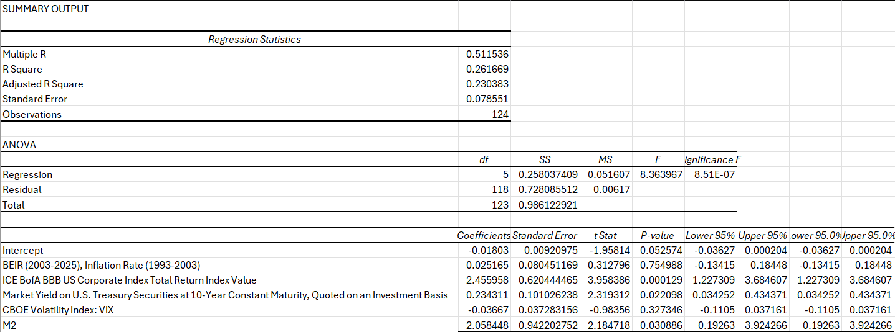
Base Regression Model (BBC no control)
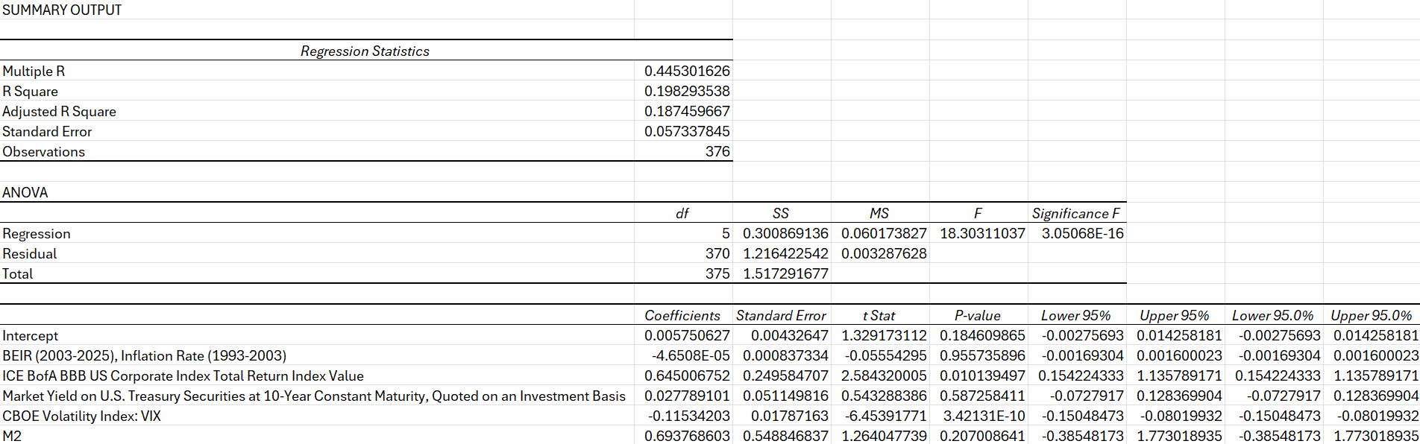
Base Regression Model (NBI no control)

Analysis of Base Regression Models
BBC Base Model (No control)
The base regression model for the clinical-stage biotech companies (BBC) explains approximately 26.2% of the variance in BBC performance (R^2=.262, Adjusted R^2=.230). The model shows strong statistical significance (F=8.37, p<.0001), with better explanatory power than the NBI model despite fewer observations, which points towards the hypothesized thesis that macro conditions create have a butterfly effect on the micro to small cap biotech companies (micro-small cap companies were responsible for 56% of New Molecular Entities in 2023.)

Key Findings:
- BBB Corporate Bond Index shows an exceptionally strong positive relationship with BBC (coefficient= 2.456, t-stat = 3.96, p< .001). This coefficient is nearly four times larger than the corresponding coefficient for NBI, suggesting that clinical-stage biotech companies are substantially more sensitive to credit conditions than the broader biotech sector. To be clear this does not represent the credit yield, instead it represents the corporate bond value.
- Treasury Yields demonstrate a significant positive relationship with BBC (coefficient=.234, t-stat=2.32, p=.022), suggesting that interest rate environments meaningfully impact clinical-stage companies, with higher yields associated with better performance, which is in contradiction to the hypothesized and understood market conditions that typically drive equity value. The intuition behind this can be the conditions and market sentiment (and rationality thereof) that follows a time of higher Treasury Yields- essentially more accurate equity value and alleviation of opportunity costs seen during blow off the top markets.
- Money Supply (M2) displays a significant positive relationship with the BBC (coefficient = 2.058, t-stat= 2.18, p=.031), indicating that monetary policy conditions substantially influence clinical-stage biotech companies.
- Market Volatility (VIX) does not show a statistically significant relationship with the BBC yet knowing its correlation to the other variables one can understand its relationship in the equation.
- Inflation Rate (BEIR) does not demonstrate a statistically significant relationship with the BBC, which is counterintuitive to the intuition built in the literature reviews and the introduction.
NBI Base Model (No Control Variables)
The base regression model for the NASDAQ Biotechnology Index (NBI) explains approximately 19.8% of the variance in NBI index performance (R^2= .198, Adjusted R^2 = .187). The model is statistically significant (F= 18.30, p<.001), indicating that these macroeconomic factors collectively have meaningful explanatory power as it pertains to the index and thus biotech equity value.
Key findings from the NBI base model (No Control Variables):
- Market Volatility (VIX) demonstrates a strong negative relationship with the NBI (coefficient= -.115, t-stat= -6.45, p<.001). This suggests that increases in market volatility can entail declines in the broader biotech sector’s performance, with each point increase in VIX associated with approximately .12% decrease in NBI returns. Giving proof of concept of the market sentiment thesis as it pertains to established cash flows.
- BBB Corporate Bond Index shows a significant positive relationship with NBI (coefficient= .645, t-stat= 2.58, p=.010). This indicates that credit conditions meaningfully impact biotech performance. Thus, improvements in the lower quality corporate bond market are associated with better biotech sector outcomes.
- Inflation Rate (BEIR), Treasury Yields, and Money Supply (M2) do not demonstrate statistically significant relationships with NBI in this base model.
Comparative Analysis and Key Differences
The comparison between NBI and BBC base models reveals several critical differences in how macroeconomic factors affect different segments of the biotech sector:
- Explanatory Power: The model explains a higher proportion of variance for clinical-stage companies (BBC: 26.2%) than for the broader biotech index (NBI: 19.8%), suggesting that macroeconomic factors had more direct influence over clinical stage companies with potential cash flows than established companies with actualized cash flows.
- Credit Conditions: The BBB Corporate Bond Index shows a dramatically stronger effect on BBC (coefficient = 2.456) compared to NBI (coefficient = .645). This nearly four-fold difference highlights the heightened sensitivity of clinical-stage companies to credit market conditions, which can be contributed to clinical stage companies need for external financing and equity valuation for proper funding of their clinical trials (without established revenue streams.)
- Interest Rate Sensitivity: Treasury yields show a significant positive relationship with BBC but not with NBI, suggesting that clinical-stage companies may be more responsive
- Monetrary Policy: Money supply (M2) significantly impacts BBC but not NBI, indicating that clinical-stage companies may benefit more directly from accommodative monetary policy, possibly through increased investment in higher-risk assets during periods of abundant liquidity.
- Volatility Effects: Market volatility (VIX) strongly influences NBI but not BBC, suggesting that established biotech companies may be more subject to general market sentiment shits, while clinical-stage companies may be driven more by company-specific factors and financing conditions.

Intuition and Review of Hypotheses
The findings in totality support the claims made in the thesis that the biotech innovation driver (micro-small cap) companies experience a butterfly effect from macroeconomic conditions particularly as it pertains to their equity valuations and paradoxical business model.
- The significantly strong relationship between BBC and credit conditions (BBB Corporate Index) confirms the hypothesis that clinical stage biotech companies face heightened sensitivity to financing environments, creating greater vulnerability during credit contractions.
- The positive relationship between BBC and Treasury yields, coupled with monetary policy sensitivity, suggests that the interest rate environment plays a complex role in biotech performance. While higher rates might typically be expected to negatively impact growth stocks and business models, they may also signal stronger economic conditions that support investment in innovation.
- The differential impact of volatility on NBI vs. BBC would suggest that market psychology may affect different segments of the biotech sector through distinct mechanisms-broader market sentiment for established companies versus financing conditions for clinical-stage firms.
- The higher R^2 for the BBC model supports the notion that macroeconomic factors may create a more binding constraint on clinical-stage companies, potentially explaining their more pronounced vulnerability during the “biotech desert” period of 2021-2025.
These two base regressions without control variables lay the foundation for the proof of concept of the thesis previously presented and lay the groundwork for the rest of the models.
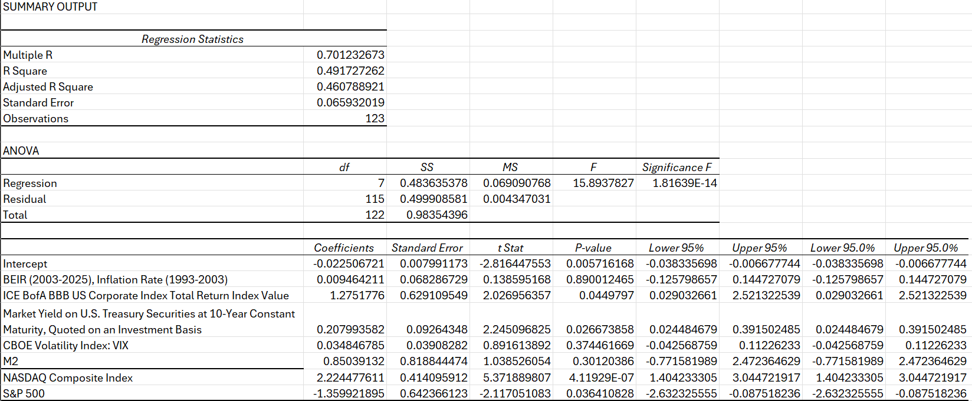
Base Regression BBC Controlled:

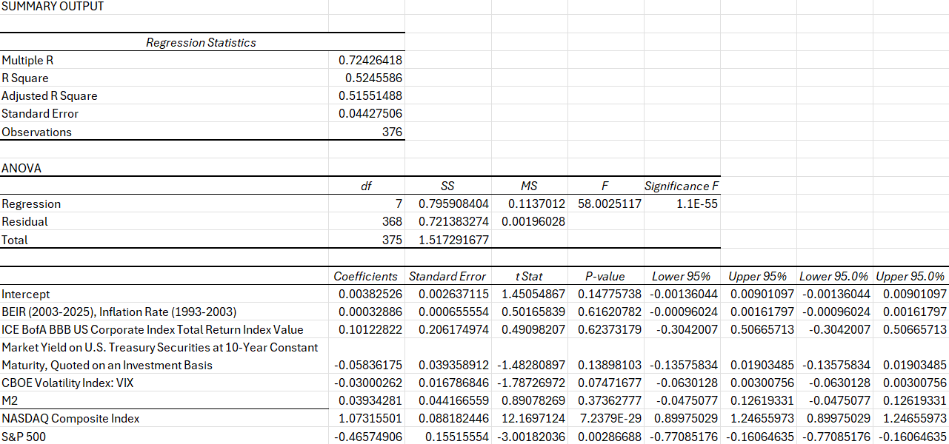
Base Regression NBI Controlled:

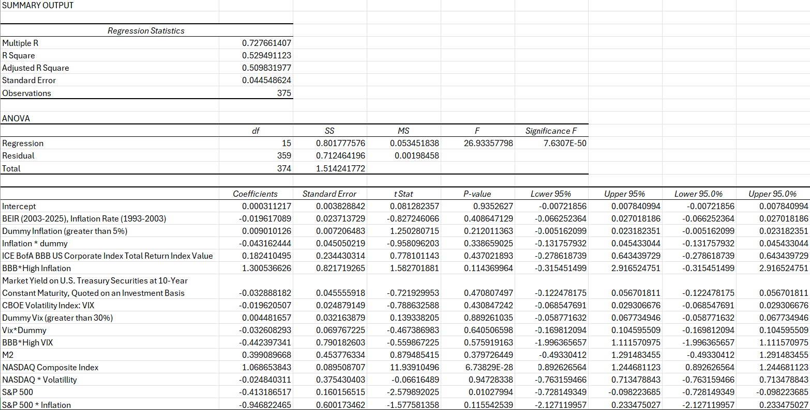
Scenario Regression NBI (BBB)

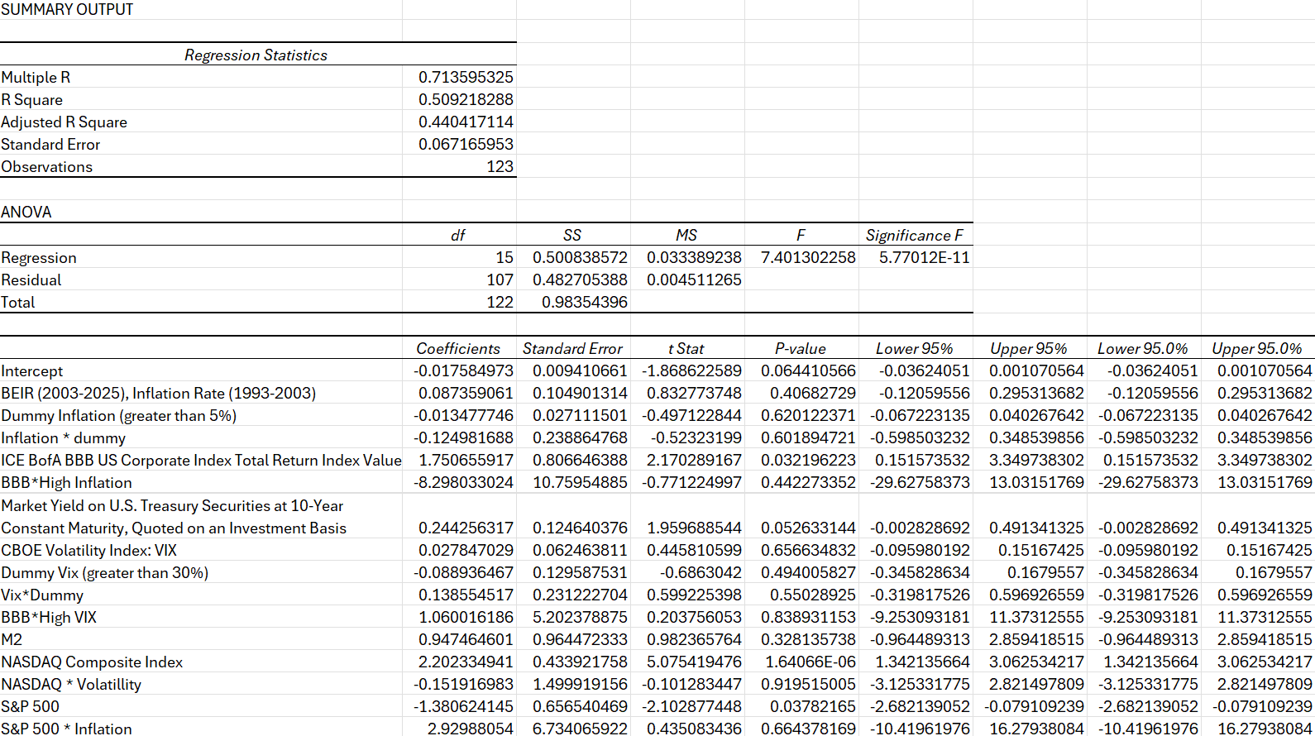
Scenario Regression BBC (BBB)

Lagged 10 Years SPY to NME y/y
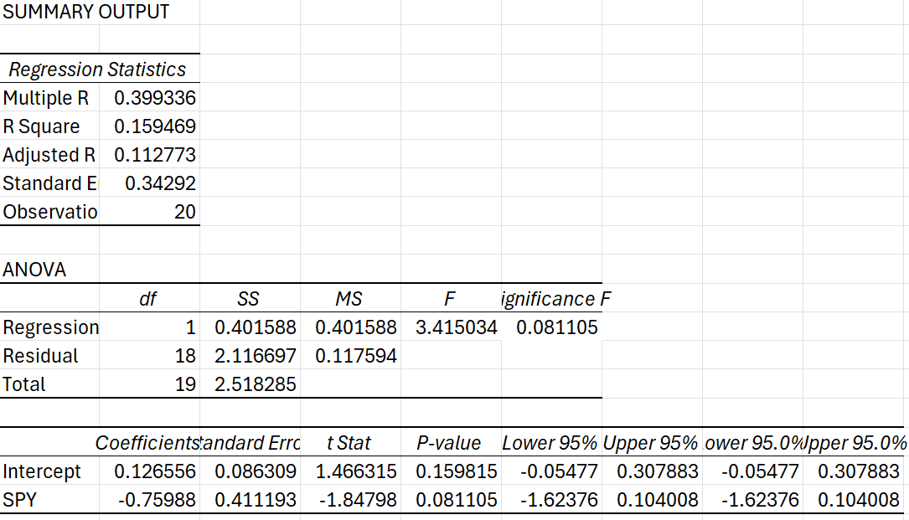

Extended Regression Analysis: Key Insights, Butterfly Effect of Innovation, and Conclusion
The controlled regression models, scenario regression models, and interaction variables provide additional insight into the investment interplay, overall market performance, and sentiment thereof as it pertains to biotech. The baseline relationships remain consistent yet utilizing the market indices: NASDAQ and S&P 500 we can control overall investment activity within the market and are able to account for more of the movement that occurs in the chosen biotech indices. Furthermore, the positive association with the NASDAQ shows the correlation in general investment and business model strategies that are experienced between technology and biotech (both being innovation driven), but the negative correlation with the S&P speaks to the volumes of potential economic hyper volatility, and flight to quality thereof, thus being attributable to opportunistic costs in the sector and creating an inefficient blow off the top market. This is also notable through the BBB Corporate Index that shows enhanced an positive coefficient with the BBC during high inflation periods vs the controlled coefficient (coefficient 1.751, p-value .032), suggesting that strong credit markets become even more critical for clinical stage companies during inflationary environments. This supports the hypothesis that inflation creates compounding challenges for early-stage biotech, as these companies become increasingly dependent on favorable credit conditions precisely when such conditions are harder to maintain. Furthermore, the Treasury yield’s positive relationship with BBC remains significant in the expanded model (coefficient .173, p-value .053), reinforcing the notion that interest rate environments have complex effects on biotech valuations beyond simple discount rate mechanics, presumably speaking to the financing difficulties for these companies during volatile market movement.
Perhaps most importantly (although the model is not as extensive), the relationship between S&P 500 performance and New Molecular Entities (NME) approvals provides the most direct evidence supporting the central thesis about macroeconomic effects on actual biotech innovation-and thus the “Butterfly Effect” thereof (which is in its most simplistic form in said regression.) The statistically significant negative coefficient evidence indicates that stronger S&P performance predicts fewer new drug approvals in subsequent periods (lagged 10 years as this is generally the amount of time clinical trialing takes.) This finding supports the intuition of equity valuations and performance to direct innovation. It suggests that capital concentration in large-cap stocks (particularly during the 2021-2025 “biotech desert” period) creates not merely a valuation gap but this valuation gap trickles down to an actual innovation deficit, as resources are diverted away from lifesaving innovation. This is especially concerning as lately this has been through investment vehicles of theoretical timelines and actualization amounts. This is not to be confused with biotech in which innovation has potential cash flows with tangible timelines and actualizations in revenue that are projectable. In summation, the findings support the paper’s argument that opportunistic cost and inefficient markets thereof driven by market psychology and macroeconomic conditions are highly detrimental and a slippery slope that should be addressed through accommodation of financial intermediatory vehicles (to bridge funding and knowledge of asset analysis gaps), financial derivatives (to hedge clinical risks and concentration of investment), and policy makers (to derive a capital market that is more aligned with humanity’s most essential resource.)

Limitations
Given more time I could implement more innovative metrics other than just the NME regression, as I have collected much of the data. Also, I would be more able to easily tie the intuition of the later regression models that lack intuition and analytical rigor. Also, I would have liked to create a regression detailing the investment landscapes, as it pertains to indices displayed above during the Internet boom and bust, and how the presumed macroeconomic variables would have impacted the equity values thereof and compare that to today’s “biotech desert.” Although, given time and my inability to have enough time to rigorously break down each regression, I felt any additional information, without analytical rigor and intuition, could have potentially sidetracked the reader towards the main thesis of the paper. The same goes as it pertains to the innovation metrics and potential charts that could have been displayed. There is a lot of intuition that I have attempted to build in this paper, so it is my assumption that digestibility is of the upmost importance in this instance. Especially if I am unable to thoroughly provide the proper intuition given the lack of time.

Appendix
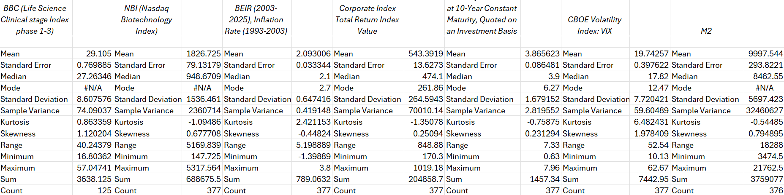
Base Summary Statistics (Table 1):

Control Variable Summary Statistics (Table 2):
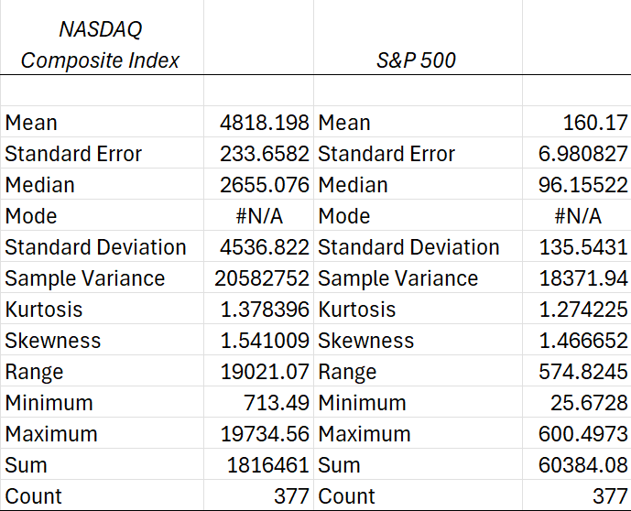

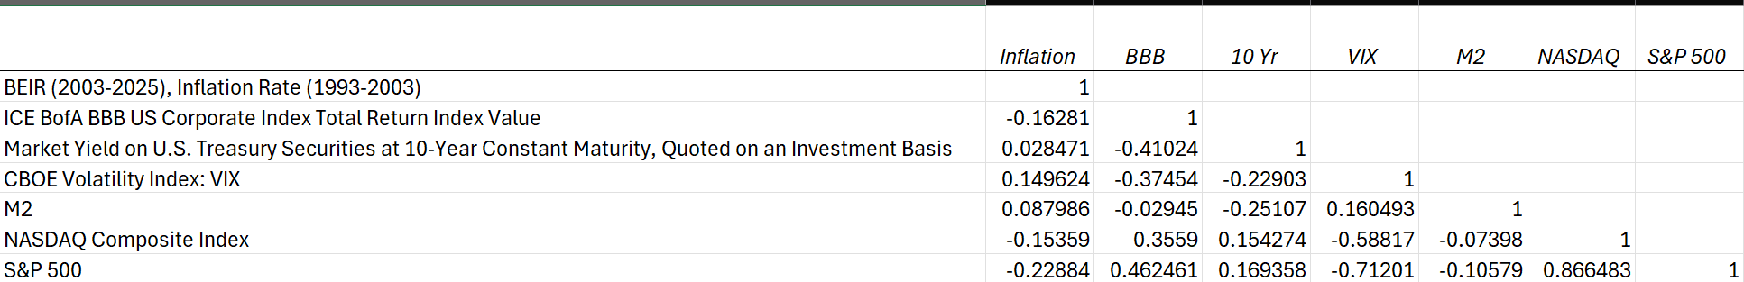
Base Correlation Matrix (Table 3):

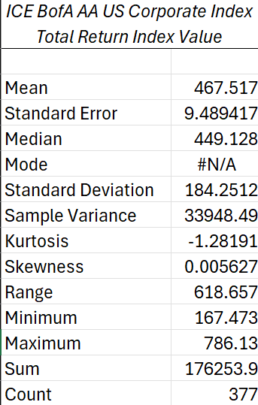
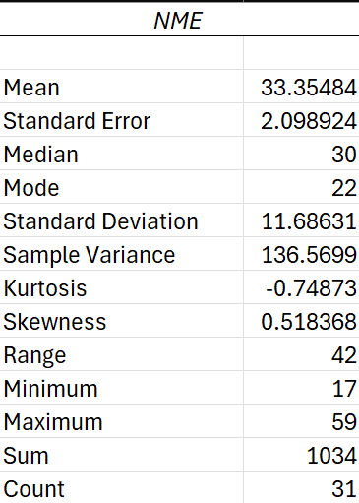
Additional Variable Summary Statistics (Table 4):

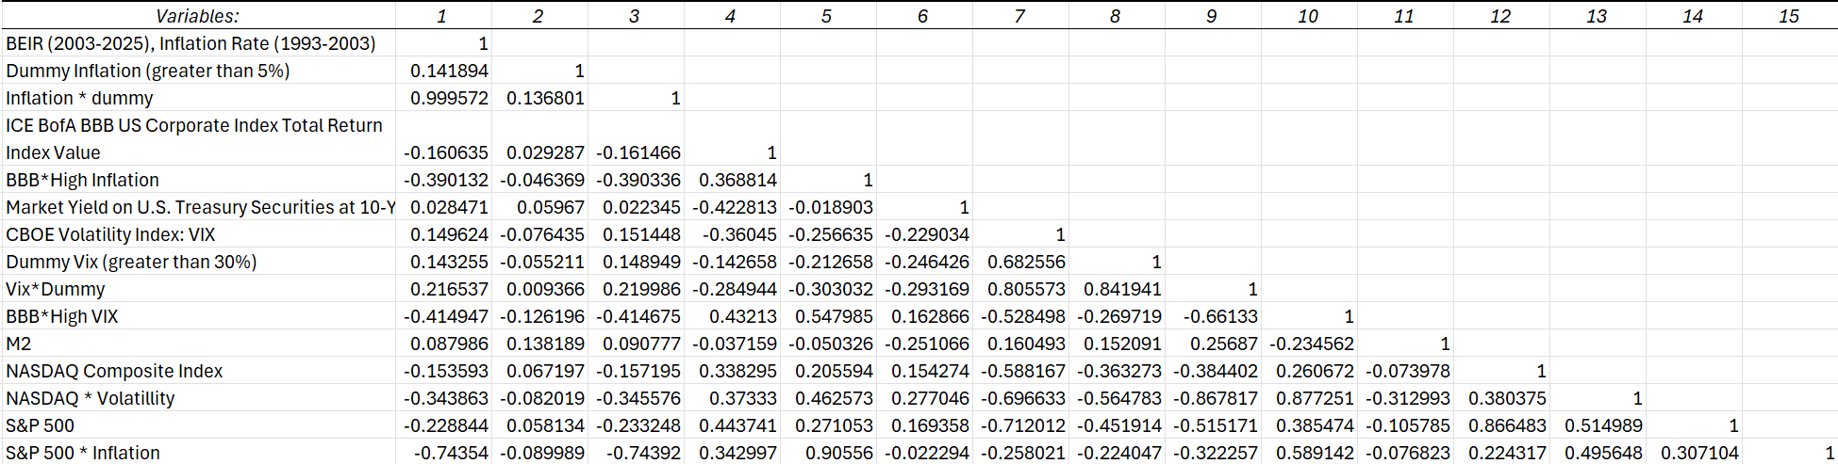
Flight to Quality (BBB) Correlation Matrix (Table 5):

ICE Bofa AA US Corporate Index Total Return Index Value Summary Statistics (Table 6)
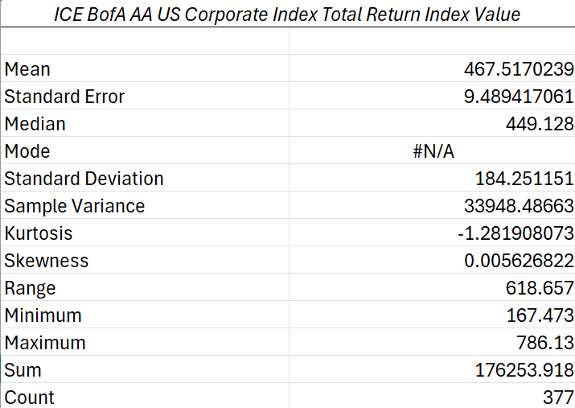

Scenario Regression (BBC) (ICE Bofa AA US Corporate Index Total Return Index Value) (Table 7)
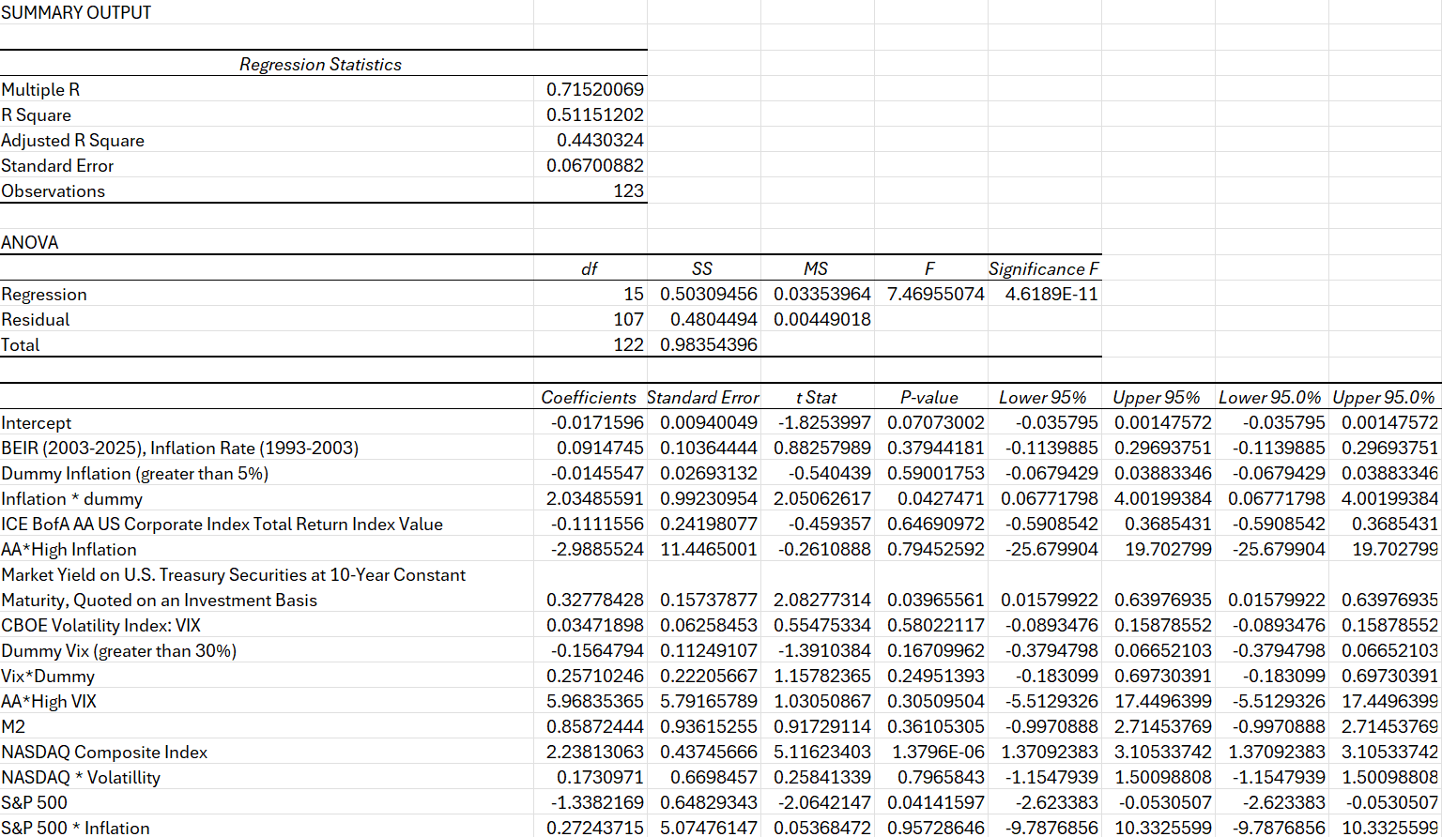

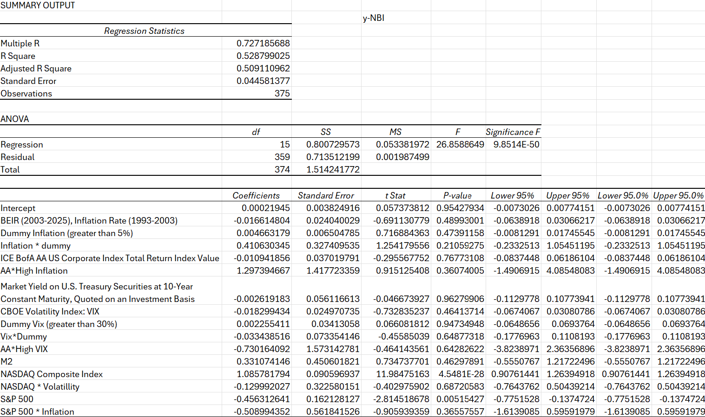
Scenario Regression (NBI) (ICE Bofa AA US Corporate Index Total Return Index Value) (Table 8)

Bibliography

Coulter, B. (2023). Understanding clinical trials cost breakdown & how to optimize it. Retrieved from https://stayrelevant.globant.com/en/technology/healthcare-life-sciences/clinical-trials-cost-breakdown/
Commissioner, O. of the. (n.d.). NDA approvals and receipts since 1938. Retrieved from https://www.fda.gov/about-fda/histories-fda-regulated-products/summary-nda-approvals-receipts-1938-present
Consulting, A., & Alacrita Pharma & Biotech Consulting. (n.d.). The road to approval: Navigating the clinical drug development process. Retrieved from https://www.alacrita.com/blog/navigating-the-clinical-drug-development-process
Ledesma, P. (2024). The ultimate guide to clinical trial costs in 2025. Retrieved from https://www.sofpromed.com/ultimate-guide-clinical-trial-costs
Ledesma, P. (2024a). What is the actual cost of a clinical trial? Retrieved from https://www.sofpromed.com/what-is-the-cost-of-a-clinical-trial
Pandas Developer (Data Reader) (yfinance) (Python). (n.d.).
(N.d.-a). Retrieved from https://www.ohe.org/wp-content/uploads/2014/07/380-RD-Cost-NME-Mestre-Ferrandiz-2012.pdf
Welcome to fred, Federal Reserve Economic Data. your trusted source for economic data since 1991. (n.d.). Retrieved from https://fred.stlouisfed.org/

